1.
Open your own laptop or desktop (or use an online PC hardware simulator if you don't have access to a real system) and identify the GPU model installed. Write down the GPU's brand, model number, and whether it is integrated or dedicated.

Gigabyte
GeForce GT 710
Dedicated GPU

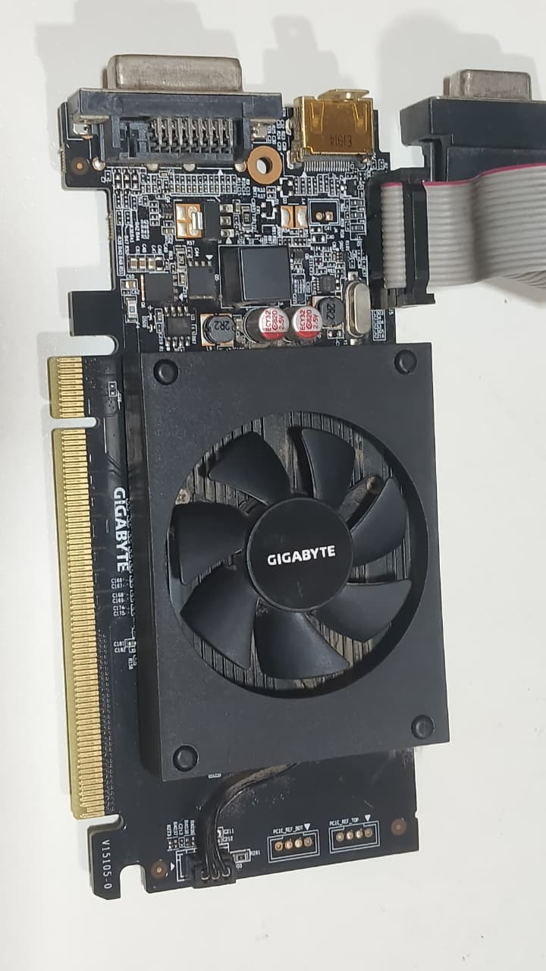

2.
Take a clear photo or screenshot of the cooling system (fan, heatsink, or liquid cooling setup) inside your PC or from a PC hardware simulator. Label the main cooling components and briefly describe their function.
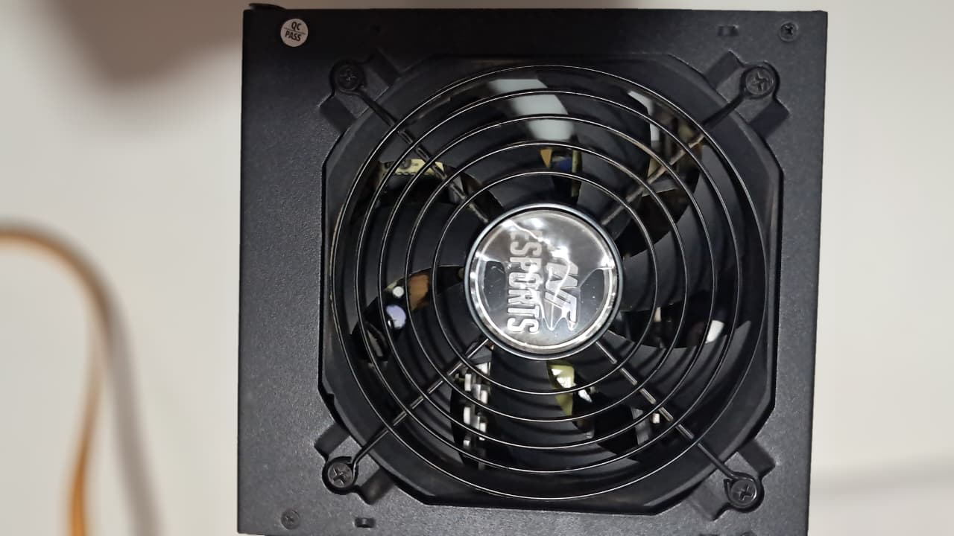
COOLING FAN:
FUNCTION: Moves air through the case
Pulls cool air in and pushes out hot air.

3.
Create a comparison table listing at least 3 differences between air cooling and liquid cooling systems for GPUs, including factors like cost, efficiency, and maintenance.
Feature | Air Cooling | Liquid Cooling
Cost | Cheaper, widely available | More expensive, premium option
Efficiency | Good for mid-range GPUs, but struggles with high heat loads | Superior cooling, handles overclocking and high-end GPUs
Maintenance | Low (just dust cleaning) | Higher (risk of leaks, needs periodic checks)
Noise | Louder at high RPM | Quieter, as fans run slower
Installation | Easy, beginner-friendly | Complex, requires careful setup

4.
Imagine you are building a gaming PC for streaming IPL matches and playing graphics-heavy games. Choose between air cooling and liquid cooling for your GPU, and justify your choice in 3-4 sentences based on your research.
I’d recommend air cooling:
- It’s cost-effective and reliable for long streaming sessions.
- Modern high-performance air coolers can easily handle GPUs used for gaming and streaming without overheating.
- Liquid cooling is excellent but adds complexity and maintenance, which may not be necessary unless you’re overclocking or using ultra-high-end GPUs.

